20 C# Programs Assignment

By

B.P.N.V.S.Sudheer

27-01-22

5. WACP To Print Fionacci Series

using System;

using System.Collections.Generic;

using System.Linq;

using System.Text;

using System.Threading.Tasks;

namespace _1

{

internal class Program

{

static void Main(string[] args)

{

int n, a = 0, b = 1, c, i;

Console.WriteLine("Enter the number of terms : ");

n =Convert.ToInt32.(Console.ReadLine());

for (i = 0; i < n; i++)

{

if (i <= 1)

c = i;

else

{

c = a + b;

a = b;

b = c;

}

Console.WriteLine(c);

}

Console.ReadLine();

}

}

}

Output :

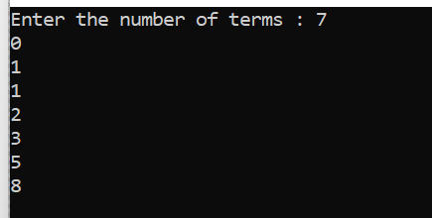

6 . WACP To Print Armstrong number

using System;

using System.Collections.Generic;

using System.Linq;

using System.Text;

using System.Threading.Tasks;

namespace _1

{

internal class Program

{

static void Main(string[] args)

{

int number, remainder, sum = 0;

Console.Write("enter the Number");

number = Convert.ToInt32(Console.ReadLine());

for (int i = number; i > 0; i = i / 10)

{

remainder = i % 10;

sum = sum + remainder * remainder * remainder;

}

if (sum == number)

{

Console.WriteLine("Entered Number is an Armstrong Number");

}

else

Console.WriteLine("Entered Number is not an Armstrong Number");

Console.ReadLine();

}

}

}

Output :

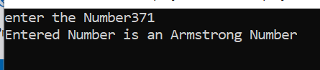

7. WACP To Print Reverse Of a Given Number

using System;

using System.Collections.Generic;

using System.Linq;

using System.Text;

using System.Threading.Tasks;

namespace _1

{

internal class Program

{

static void Main(string[] args)

{

Console.WriteLine("Enter a No. to reverse");

int Number = Convert.ToInt32(Console.ReadLine());

int Reverse = 0;

while (Number > 0)

{

int remainder = Number % 10;

Reverse = (Reverse * 10) + remainder;

Number = Number / 10;

}

Console.WriteLine("Reverse No. is {0}", Reverse);

Console.ReadLine();

}

}

}

Output :

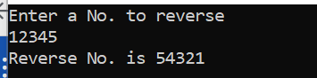

8. WACP TO print Sum of Numbers

using System;

using System.Collections.Generic;

using System.Linq;

using System.Text;

using System.Threading.Tasks;

namespace _1

{

internal class Program

{

static void Main(string[] args)

{

int fn, sn, sum = 0;

Console.WriteLine("enter first number");

fn = Convert.ToInt32(Console.ReadLine());

Console.WriteLine("enter second number");

sn = Convert.ToInt32(Console.ReadLine());

sum = fn + sn;

Console.WriteLine(sum);

Console.ReadLine();

}

}

}

Output :

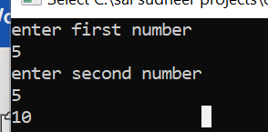

9. WACP TO Print Palindrome Number

using System;

using System.Collections.Generic;

using System.Linq;

using System.Text;

using System.Threading.Tasks;

namespace _1

{

internal class Program

{

static void Main(string[] args)

{

int num, rem, sum = 0, temp;

Console.WriteLine(" Enter a number: ");

num = Convert.ToInt32(Console.ReadLine());

temp = num;

while (num > 0)

{

rem = num % 10;

num = num / 10;

sum = sum * 10 + rem;

}

Console.WriteLine("\n The Reversed Number is: {0} \n", sum);

if (temp == sum)

{

Console.WriteLine("\n Number is Palindrome \n\n");

}

else

{

Console.WriteLine("\n Number is not a palindrome \n\n");

}

Console.ReadLine();

}

}

}

Output :

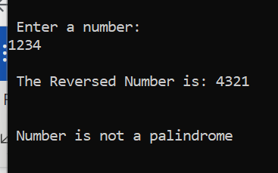

10. WACP To Print Swap Number using Third Variable

using System;

using System.Collections.Generic;

using System.Linq;

using System.Text;

using System.Threading.Tasks;

namespace _1

{

internal class Program

{

static void Main(string[] args)

{

{

int a = 5, b = 3, temp;

temp = a;

a = b;

b = temp;

Console.WriteLine("Values after swapping are:");

Console.WriteLine("a=" + a);

Console.WriteLine("b=" + b);

Console.ReadLine();

}

}

}

}

Output :

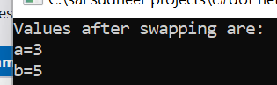

11. WACP TO Print Without Using Third Variable

using System;

using System.Collections.Generic;

using System.Linq;

using System.Text;

using System.Threading.Tasks;

namespace _1

{

internal class Program

{

static void Main(string[] args)

{

{

int a = 10, b = 20;

a = a + b;

b = a - b;

a = a - b;

Console.WriteLine("Values after swapping are:");

Console.WriteLine("a=" + a);

Console.WriteLine("b=" + b);

Console.ReadLine();

}

}

}

}

Output:

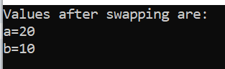

12. WACP TO Print Stars in Pattern

using System;

using System.Collections.Generic;

using System.Linq;

using System.Text;

using System.Threading.Tasks;

namespace _1

{

internal class Program

{

static void Main(string[] args)

{

for (int row = 1; row <= 8; ++row)

{

for (int col = 1; col <= row; ++col)

{

Console.Write("*");

}

Console.WriteLine();

Console.ReadLine();

}

}

}

}

Output :

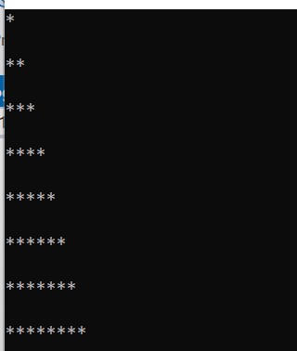

13 . WACP To Print Factorial Number using Recursion

using System;

using System.Collections.Generic;

using System.Linq;

using System.Text;

using System.Threading.Tasks;

namespace _1

{

internal class Program

{

public static void Printoutput(int n)

{

Console.WriteLine("factorial of {0} = {1}", n, factorial(n));

}

public static int factorial(int n)

{

if (n == 0)

return 1;

else

return n * factorial(n - 1);

}

static void Main (String [] args)

{

int n =5 , n1 =6 , n2 = 7;

Printoutput(n);

Printoutput(n1);

Printoutput(n2);

Console.ReadLine();

}

}

}

Output:

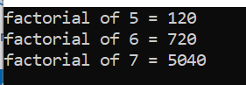

14. WACP TO Print Power of a Given Number

using System;

using System.Collections.Generic;

using System.Linq;

using System.Text;

using System.Threading.Tasks;

Namespace _1

{

internal class Program

{

static void Main (string [] args)

{

int a, b, result = 1, i;

Console.WriteLine("Enter value of a");

a = Convert.ToInt32(Console.ReadLine());

Console.WriteLine("enter value of b");

b = Convert.ToInt32(Console.ReadLine());

for (i = 1; i <= b; i++)

result = result * a;

Console.WriteLine(result);

Console.ReadLine();

}

}

}

OutPut :

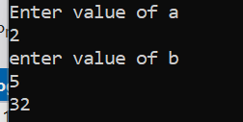

15. WACP TO Print Factor of a Given Number

using System;

using System.Collections.Generic;

using System.Linq;

using System.Text;

using System.Threading.Tasks;

namespace _1

{

internal class Program

{

static void Main (string [] args)

{

int input, i;

Console.WriteLine("Enter any Number");

input = Convert.ToInt32(Console.ReadLine());

for ( i =1; i <= input; i++)

{

if (input % i == 0)

Console.WriteLine(i);

}

Console.ReadLine();

}

}

}

Output :

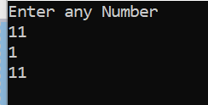

15. WACP To Print Factorial number using Function

using System;

using System.Collections.Generic;

using System.Linq;

using System.Text;

using System.Threading.Tasks;

namespace _1

{

internal class Program

{

public static void Printoutput(int n)

{

Console.WriteLine("factorial of {0} = {1}", n, factorial(n));

}

public static int factorial(int n)

{

int fact = 1;

for (int i = 1; i <= n; i++)

fact = fact * i;

return fact;

}

static void Main(String[] args)

{

int n = 5, n1 = 6, n2 = 7;

Printoutput(n);

Printoutput(n1);

Printoutput(n2);

Console.ReadLine();

}

Output :





